**Envi-city: Vision of a Sustainable Smart City of the Future**

P. Dasa, E. Vijayaragavanb, A. Sarkarc, and R. S. Kumara

a Department of Electronics & Communication Engineering, SRM Institute of Science and Technology, Kattankulathur, Tamil Nadu 603203, India

b Department of Mechanical Engineering, SRM Institute of Science and Technology, Kattankulathur, Tamil Nadu 603203, India

c Department of Electronics & Telecommunication Engineering, Jadavpur University, Kolkata, West Bengal 700032, India

Our main objective is to change people's perspective on an unbalanced city by viewing a new world through sustainable development goals. When we relate sustainability and a city there are important things to look upon and make a change on it. Some of the problems looked upon are: (i) Reduction in the number of birds due to electromagnetic radiation, (ii) 8-15% loss between powerplant and consumers, (iii) air pollution, (iv) Waterlogging in city pockets and waste management. The final vision is to make a smart eco-city run fully on renewable energy. Using sustainable energy sources by fitting rooftop solar cells in every house and placing vertical turbines on the roadside reduces the dependency on fossil fuels and can generate employment in many technical fields. We shall even have automated air purifiers run by solar cells, which purify the air depending on the real-time PPM levels of dust and gasses. The smart city that we have a vision of filters out high bandwidth signal waves for mobile and telecommunication while utilizing short-range Wi-Fi devices interconnected with WAN cables which can reduce the harmful effects of high energy electromagnetic radiation on birds. This is an IoT-based city where most of the electronics and other devices are connected, running on automation for easing day-to-day activities. Implementing this project will produce a positive change in the ecosystem.

Keywords: Internet of things; Sustainable; Eco friendly; Smart city; Flood management; Smart connectivity; Green city.

* Corresponding author Email address: [pd7000@srmist.edu.in](mailto:pd7000@srmist.edu.in)

**Method Descriptions**

The framework of the “Envi-city” is quite simple — it is a well-planned city run on renewable energy with automated rain and flood water management, a low-power air purification system along with an extended network of green spaces, and specially designed e-vehicles to keep carbon levels within safe limits. The city is digitally connected through cables and optical fibers which facilitate all phone calls which would ultimately lead to a reduction in the number of towers and lead to a better environment for the birds. The city will be powered mainly by solar energy and, if possible, nuclear energy. There will also be the provision of wind energy which will be provided by vertical turbines placed strategically in areas with adequate winds like riversides or beaches. We want to avoid large windmills because they also pose hazards to birds. Hence, we have discussed some of the proposed solutions in detail with supporting diagrams for better understanding.

Renewable Power Supply Chain

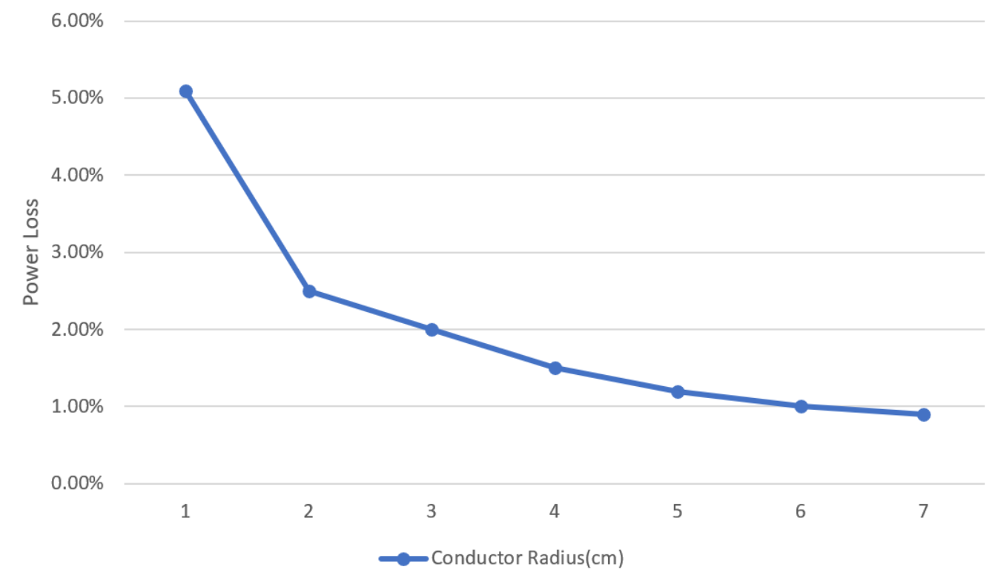 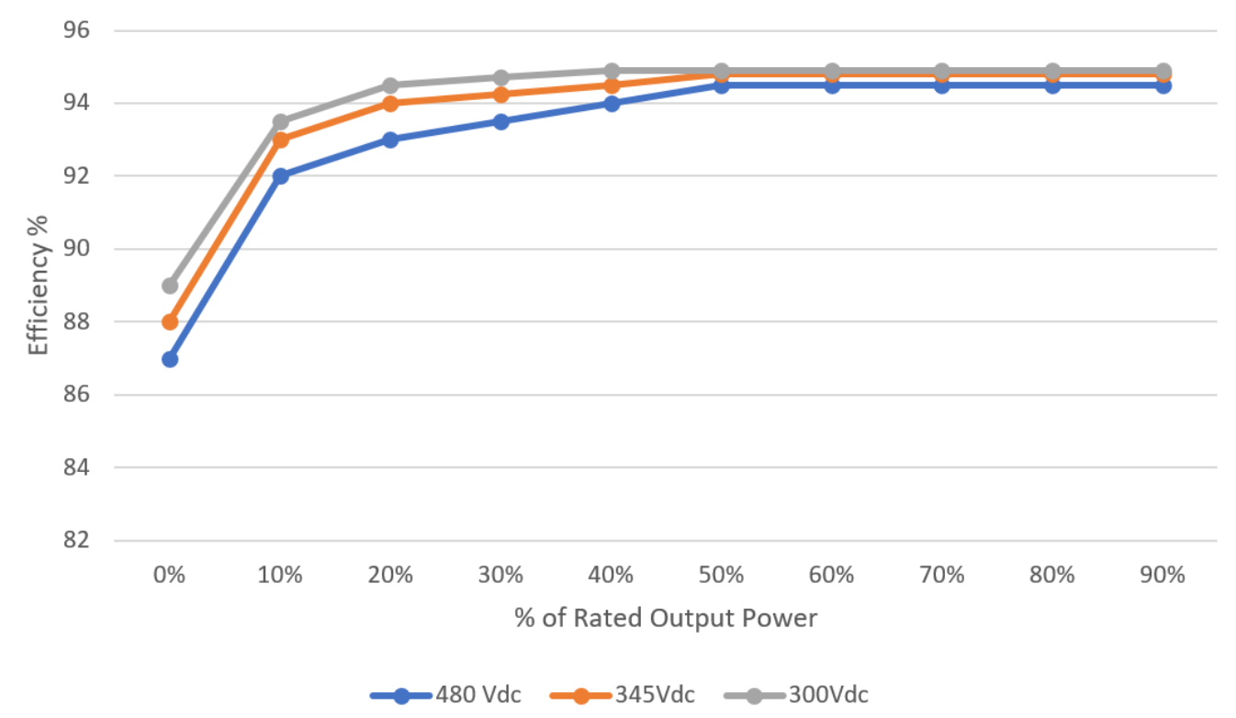

(a) (b)

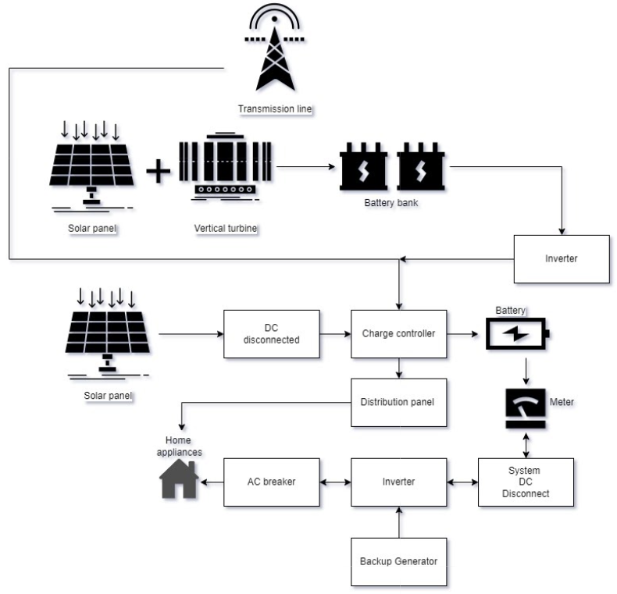

(c)

Figure 1. (a) Power loss in % as a function of the radius of the wire (High voltage wires require thicker cables); (b) % Efficiency of solar power output; (c) Net power distribution system.

The city shall be powered by large solar farms and a chain of vertical wind turbines maintained by the government. We want to keep the use of non-renewables as low as possible (The city may start with not more than 50% of its power supplied from traditional fossil fuel-based power plants which will be gradually phased out depending on consumption and efficiency). This will be supplemented by energy stored by solar panels fixed on every roof-top in the city. We want to prioritize such renewable energy not only because of environmental reasons but also because there is a significant loss of energy as consumers receive only a fraction of that produced in the power plant.

Smart Rainwater and Floodwater Management

Nowadays, various areas in the world have faced waterlogging and salinity problems. Such waterlogging or flooding is harmful in cities where toxic drain water gets mixed. In farmlands, such flooding may be undesirable as some crops are destroyed in excess soil water.

Envi-city has a control unit to store water, divided into two sections, floodwater and rainwater management to be utilized for agricultural automation purposes through the drainage system. Envi-city has 4 types of drainage systems:

1. Surface Drainage System.— open drains, humps, hollows, and grassed waterways
2. Subsurface Drainage System.— dig ditches to install the pipes of subsurface drains
3. Slope Drainage System.— installed pipe is anchored to an incline in the mountains
4. Downspouts and Gutter System.— downspouts and gutter systems against over-saturation from stormwater.

The control system of our design can be very well managed from PC or mobile applications. There are different integrated sensors and devices. There is one central server that interconnects the integrated sensors and devices, via wireless modules. Internet connectivity from the users’ end makes the server receive and send information to act on. The robot has various sensors and devices like a camera to keep an eye on, an ultrasonic sensor, an alarm to alert, a sharp slider to keep away distractions to affect it like birds or any animal that will obstruct the automation. It is an application or mobile-based robot that is controlled with a computer too, used to autonomously search within its region of the area using the GPS coordinates.

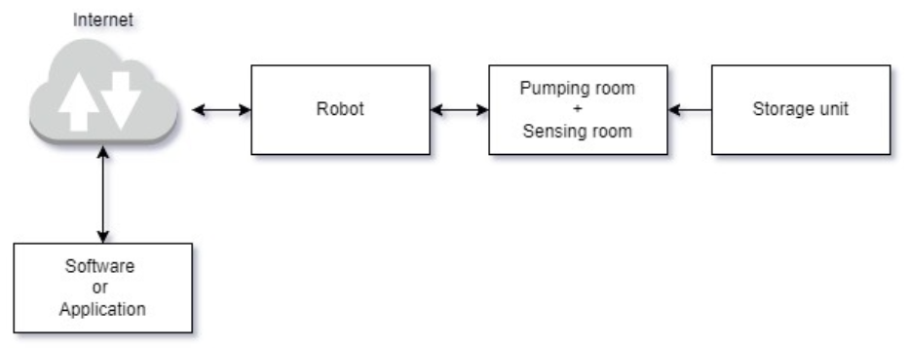

Figure 2. Basic structure of the IoT application.

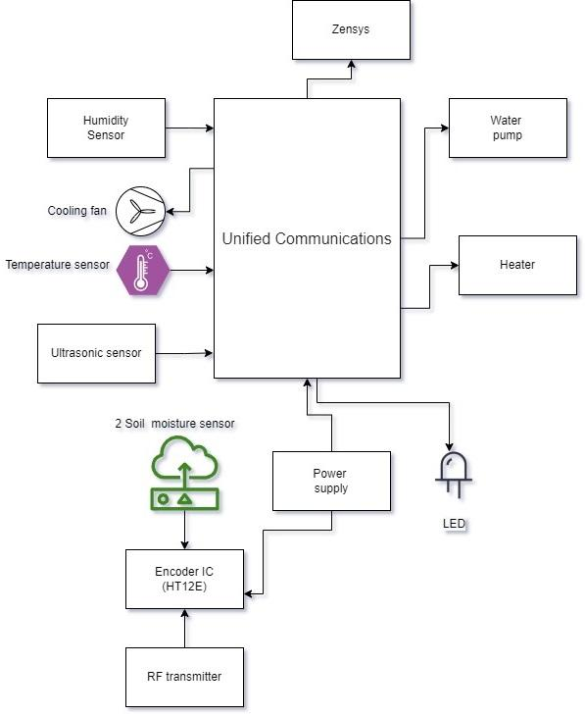 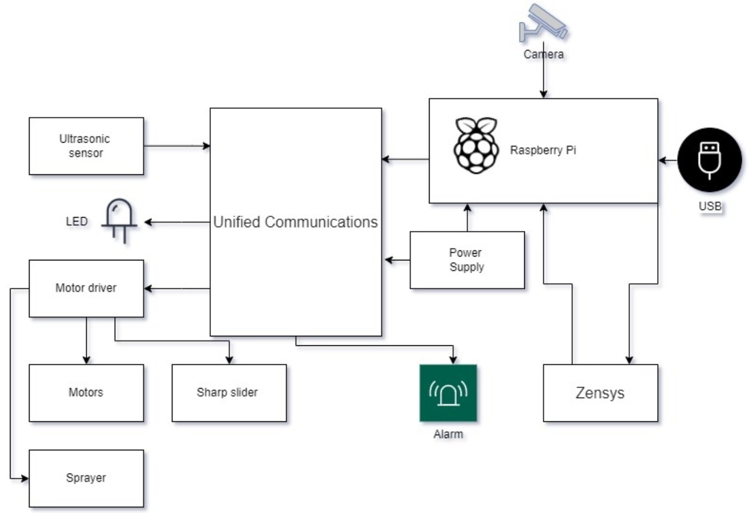

(a) (b)

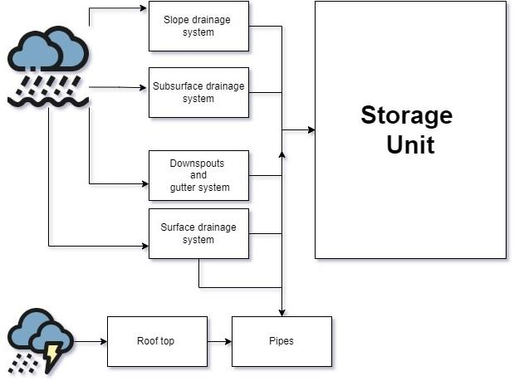

(c)

Figure 3. (a) IoT-based automated machine for the flood management system; (b) Pumping and sensing control system which controls the operation of; (b) the storage unit.

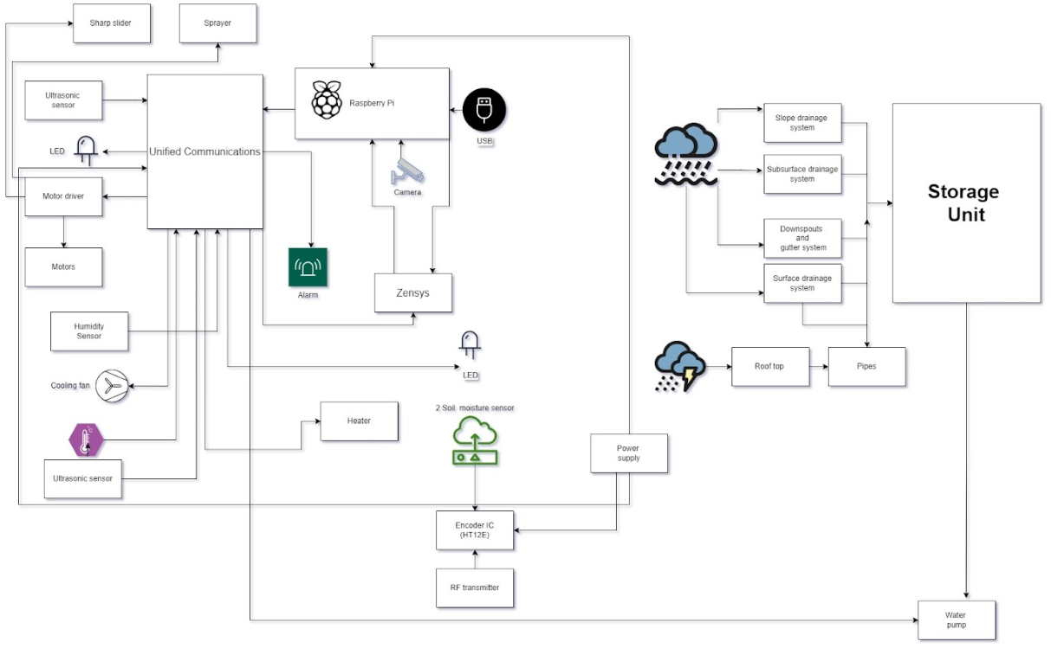

(a)

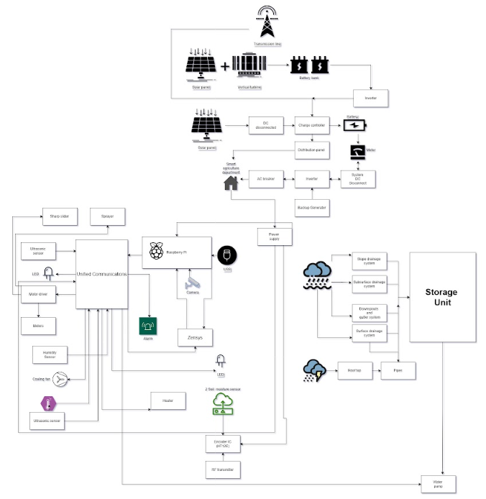

(b)

Figure 4. (a) Smart flood management system; (b) Flood management system with a power source.

In the city, rainwater will be collected from the rooftop through rainwater harvesting collecting to the drainage system stored into a water unit. The sensing room controls the water pump that is collected from the rainwater harvesting or by the flood management system depending on the real-time data collected, which automatically turns on or off after it reaches the soil moisture level in automatic mode. Through manual mode, it can also be remotely controlled as mentioned before, through a computer or a mobile, with data collected from monitoring of soil moisture. The sensing room can provide theft detection technology with the ultrasonic sensor, nothing less than a security mode to turn on and off concerning any obstruction. There are sensors like the humidity and temperature sensor which senses the value, after it crosses the threshold, the cooling fan and room heater will act accordingly.

Wi-Fi Calling

Several countries have seen a decline in bird species associated with an increase in Cellular Mobile Base (GSM 900 or 1800) channels. An outstanding example of this impact originates in the UK when a sharp decline in several species of urban birds was observed, including a sparrow. The number of sparrows in the country has dropped from 24 million to 14 million within 30 years. A sudden drop of 75% occurred between 1994 and 2002 in line with the introduction of mobile technology in the country. So our team is trying to lay down the vision of a future city where there will be no use of any cell phone towers. Instead, a well-planned WAN (Wide Area Network) will be established such that every house in every street will receive an internet connection through optical cables laid underground. Adequately protected by limited bandwidths that do not affect any living organisms. This service will be similar to gas pipelines and water lines. Routers will be placed at regular intervals to allow wireless transfer of data. It can simplify the physical association of a device to the media. Network data transmission is independent of the connected hardware, making it accessible for a device to transmit or receive data to or from another faster or slower device. And it is easy to maintain. By filtering traffic in trusted network areas the network is being secured. Specialized authentication policies are used to scrutinize network traffic.

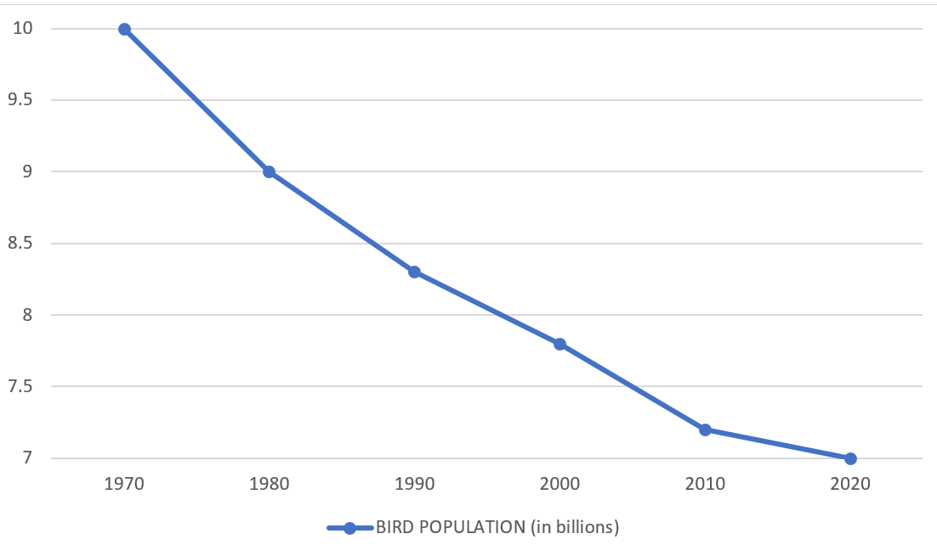 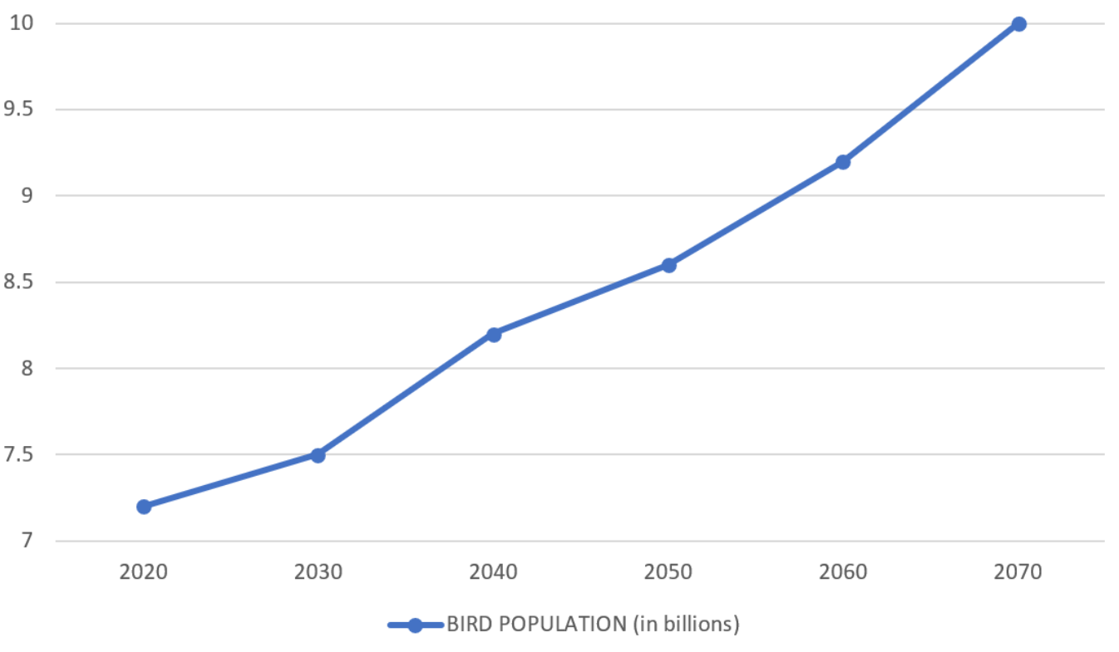

(a) (b)

Figure 5. (a) Graph showing a decline in bird population over the decades, which happened mainly due to human intervention in the ecosystem; (b) Estimated rise in population of birds over the next few decades.

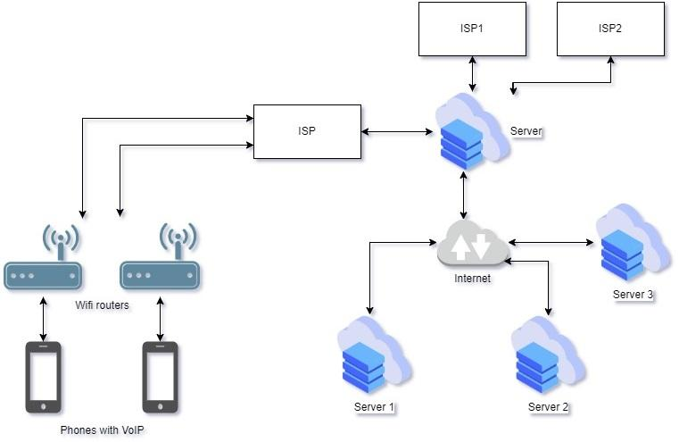

Figure 6. Wi-fi calling setup; data may be carried by cable broadband or optical fibers.

Air Purification

Though not 100% efficient, to an extent “ENVI-CITY” has houses with rooftop air-purifiers along with solar panels to create a pollution-free environment. We know that air purification can be very well concentrated when it is indoor, but “ENVI-CITY” primarily focuses on the extraction of active carbon in the environment.

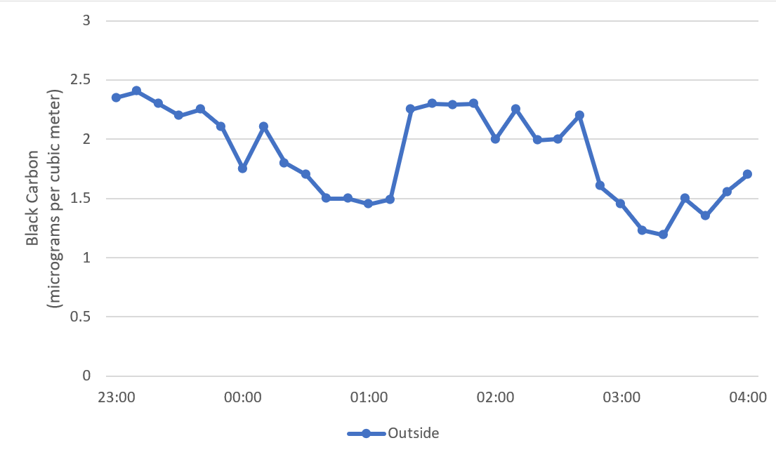

Figure 7. Daily carbon black concentration over midnight.

For this purpose, we propose putting purifiers with high-efficiency particulate air (HEPA) filters that intelligently measure the level of concerning particles and gasses using sensors, and activate themselves when they need to be. A HEPA filter is capable of disabling the free propagation of particulate matter in the air that is over 0.3 micrometers in size and achieves about 99.97% of the purification of air. The impure air enters the filter through one side and pure air is obtained from the other side. This process of passing the impure air through the filter is performed at a relatively high speed, thereby enabling quick purification. The impurities get stuck to the filter face, which is why the filter needs to be replaced frequently depending on the air quality index of the surroundings.

The energy to run the purifiers is supplied from inverters that store energy from solar panels on the same rooftops. The storage mechanism includes a system power switch that chooses between power generated by the solar panels in the roof and the power fed to individual houses coming from government-maintained solar farms.

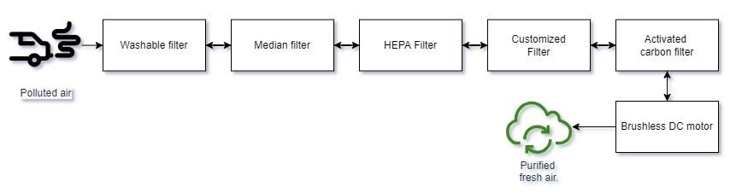

(a)

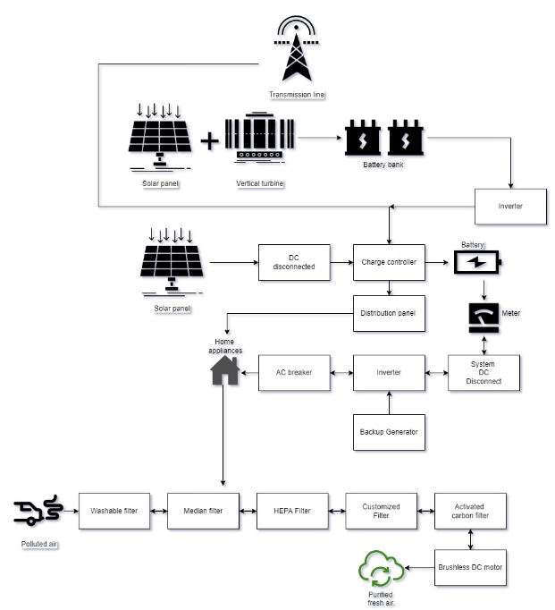

(b)

Figure 8. (a) Purification process of polluted air; (b) Purifier with power source.

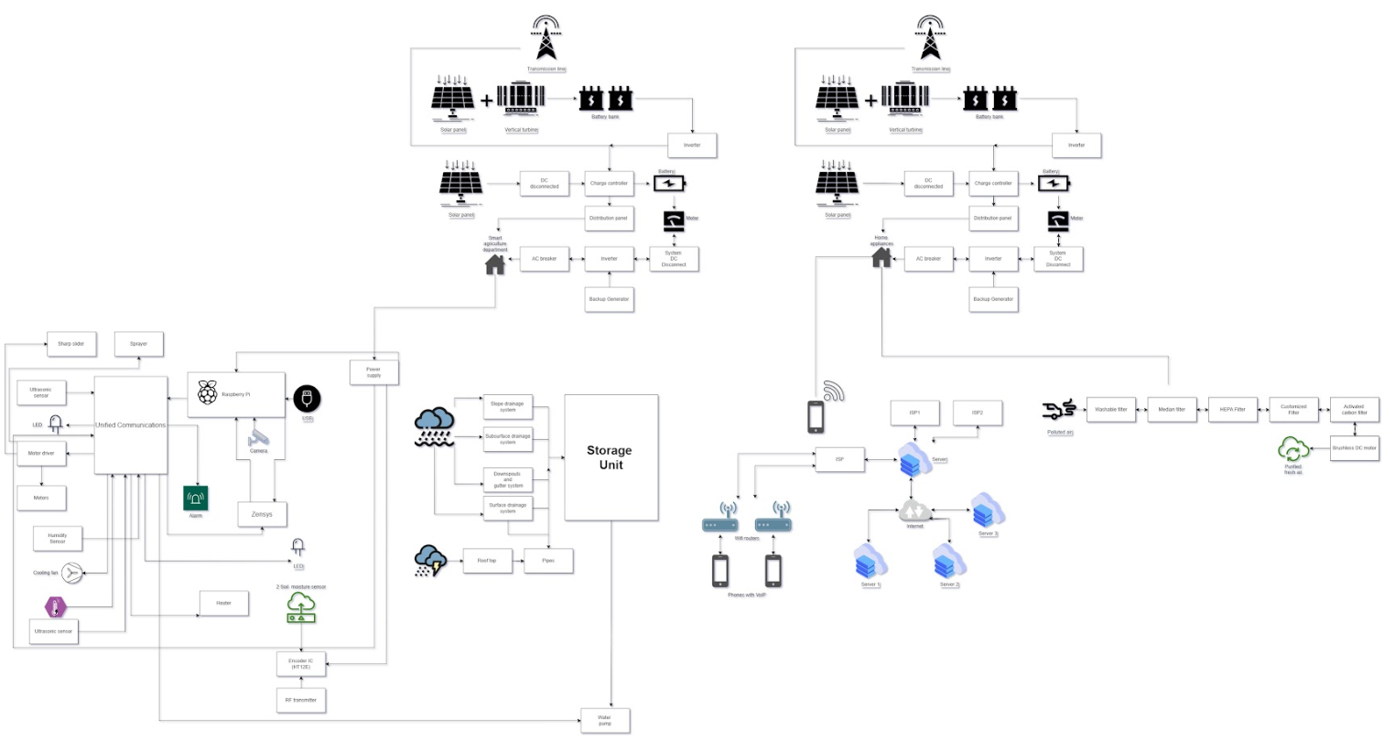

Figure 9. The “Envi-city” concept.

**Conclusion**

“Envi-city” aims at providing the world with a healthier place to survive with certain modifications. A much systematic and well-planned city run on solar farms and vertical wind turbine chains, a city that is free from the clutches of water-logging and salinity issues with the implementation of smart rainwater and floodwater management. Which gives people clean water and well planned sanitation. A city that not only focuses on human welfare but also environmental welfare as a whole, a place where Wi-Fi calling will replace cellular calling, reducing the extinction of bird species. Which is responsible for proper communication and Eco- friendly. Not to forget the air purification initiative with rooftop air purifiers. Which can be affordable and it is responsible to provide clean energy to the city. “Envi-city” comes with a promise of correcting some flaws of the society which otherwise pose a threat to the environment and thus in turn mankind.

**References**

1. Alsaihan, *Mobile WiFi-calling feature and algorithms*, Macquarie University, Sydney, Australia (2017)
2. <https://pvpmc.sandia.gov/modeling-steps/dc-to-ac-conversion/cec-inverter-test-protocol/>
3. <https://www.tutorialspoint.com/what-are-the-advantages-and-disadvantages-of-lan-in-computer-network>
4. Dhami KK. *The electromagnetic radiations and its impacts on bird diversity in India, Int J Avian & Wildlife Biol.* (2020)
5. Kumutha S, Gayathri Devi N, Mohanbabu S, *IoT Concept for Smart System Monitoring Agricultural Land*, IJERT RTICCT (2018)
6. <https://pvpmc.sandia.gov/modeling-steps/dc-to-ac>